# Lab 20: Router Basics

## Objectives

*  Create another Page (container component)
*  Add Basic Routes (install, configure)
*  Create a Navigation Menu

## Steps

### Create another Page (container component)

1. Create a HomePage component.

You will need to create a home directory.

#### src\home\HomePage.js

### Add Basic Routes (install, configure)

1. **Open** a command prompt (Windows) or terminal (Mac).
2. Change the **current directory** to code\keeptrack.

If the top level directory you have open in VS Code is keeptrack and you are using the integrated terminal you will already be in this directory.

1. **Run** the following command to install React Router:

#### npm



**Configure** the **routes**.

#### src/App.js

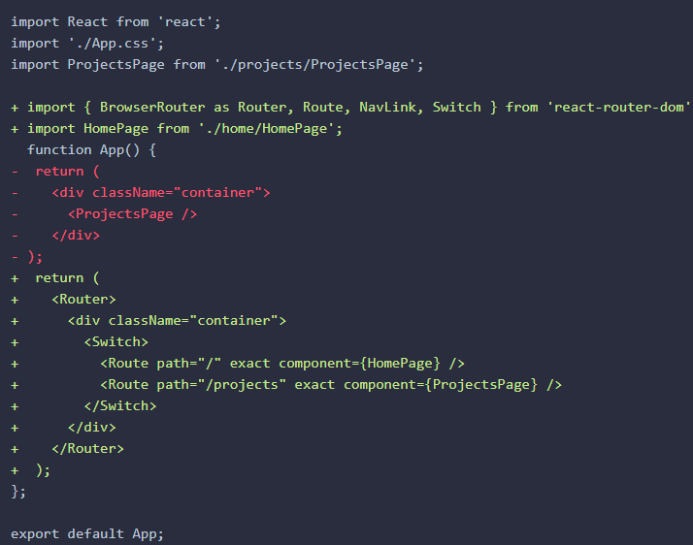

### Create a Navigation Menu

1. **Modify** your **CSS** styles to include some customizations for the navigation menu.

#### src/App.css

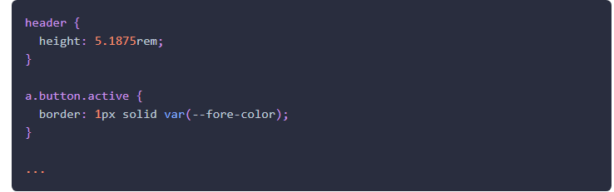

1. **Add** two <NavLink> **components** (which are provided by the React Router) and set them to visit the configured routes.

#### src/app.js

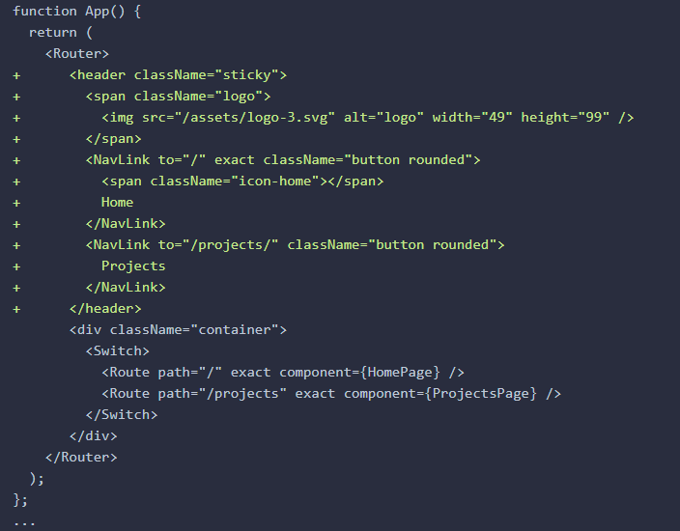

You can make any <a> tag a <NavLink> and add the to property to set the href.

You need exact in both home NavLink and Route.

* exact in the NavLink keeps Home and Projects from being active(highlighted at the same time)
* exact in the Route keeps /projects from showing Home and the projects list when going to projects route (it shows both without Switch)

**Verify** the **routes** are working by the **following these steps**:

* 1. **Visit** the root of the site: http://localhost:3000/ and refresh the page in your browser.
  2. **Click** on Projects in the **navigation**.
  3. **Verify** you are taken to the /projects route and the ProjectsPage **displays**. 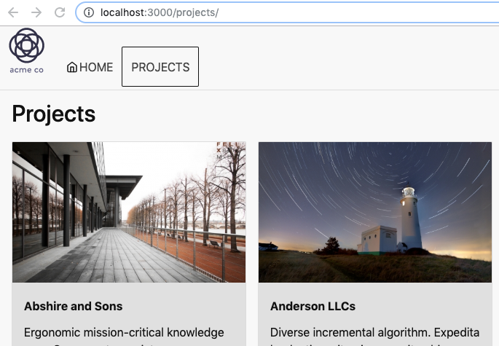
  4. **Click** on Home in the **navigation**.
  5. **Verify** you are taken to the / route and the HomePage **displays**. 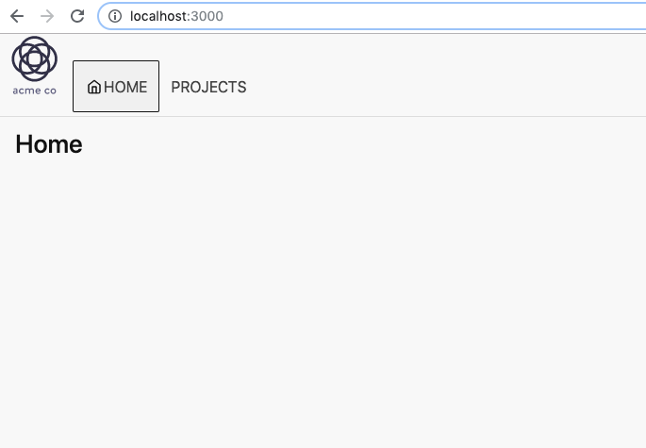

### ✔ You have completed Lab 20